Lab - Managing the Startup Folder in Windows 7 and Vista

Introduction
In this lab, you will customize the Startup Folder and the Run Key in the registry.

Recommended Equipment
- A computer running Windows 7 or Vista
- Creating a shortcut for Internet Explorer.
    - Click Start > All Programs, right-click Internet Explorer and click Send To > Desktop (create shortcut).
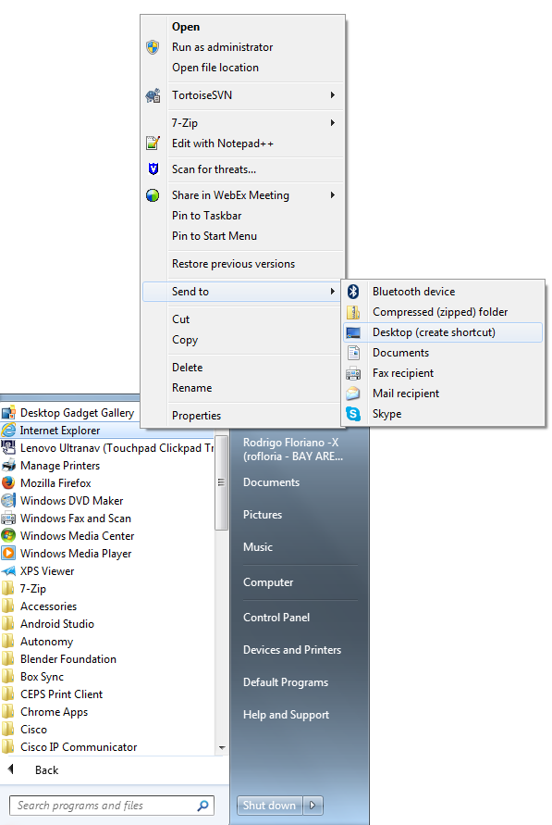
- Adding the shortcut to the Startup Menu.
    - To open the Startup folder, click Start > All Programs, right-click the Startup folder, and select Open.
    - Drag the Internet Explorer shortcut icon to the right pane of the Startup folder.
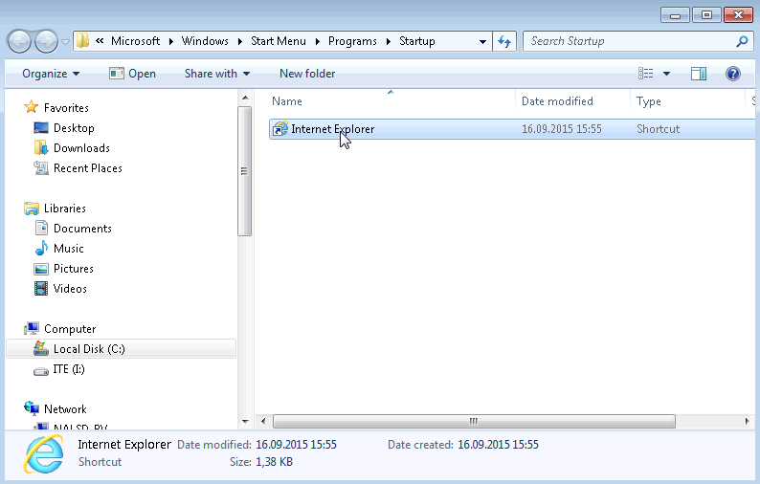
    - Restart Windows.
    - Log on to Windows as an administrator.
What happens when you log in?
____________________________________________________________________________________
    - Close Internet Explorer.
- Manage Startup applications using Windows Registry.
    - Click Start, type regedit and press Enter.
    - The Registry Editor window opens. Expand HKEY_CURRENT_USER > Software > Microsoft > Windows > CurrentVersion> Run.
Note: Incorrect changes to the registry can cause system errors and/or system instability.
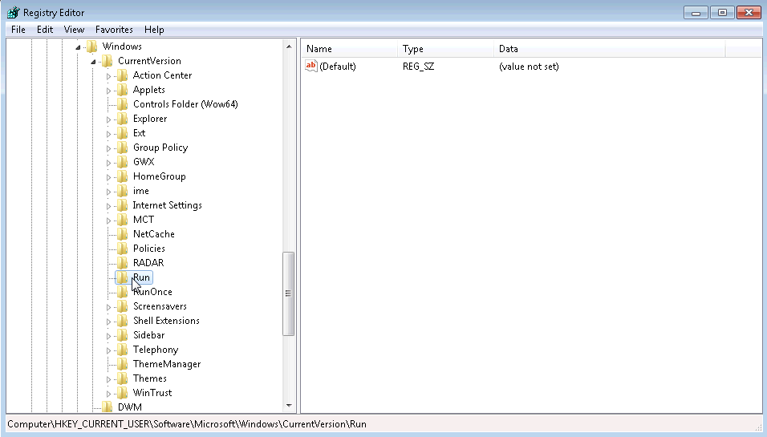
    - Right-click anywhere in the white space on the right side of the window. Select New and click String Value. A new String Value is created.
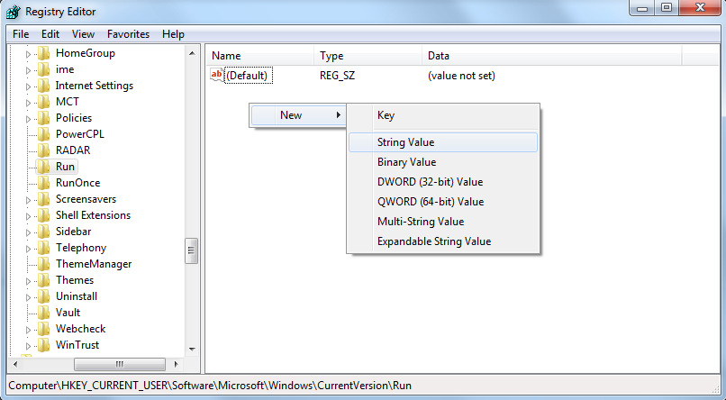
    - Click anywhere in the white space of the window.
    - Right-click New Value #1 > Rename. Type Notepad and press Enter.
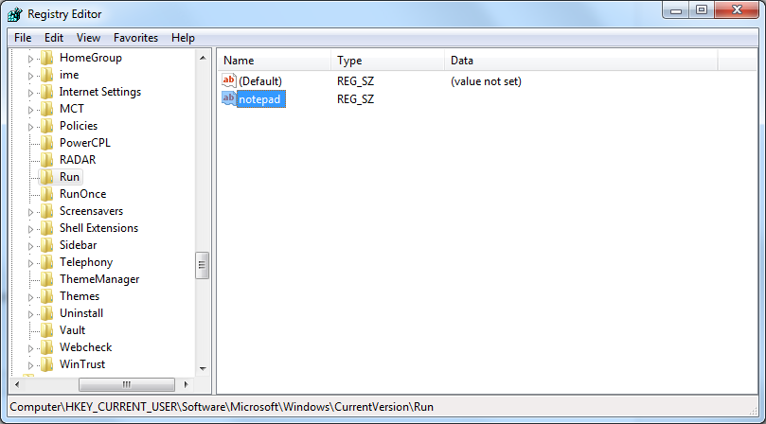
    - Right-click Notepad > Modify. Type C:\Windows\system32\notepad.exe in the Value data field. Click OK.
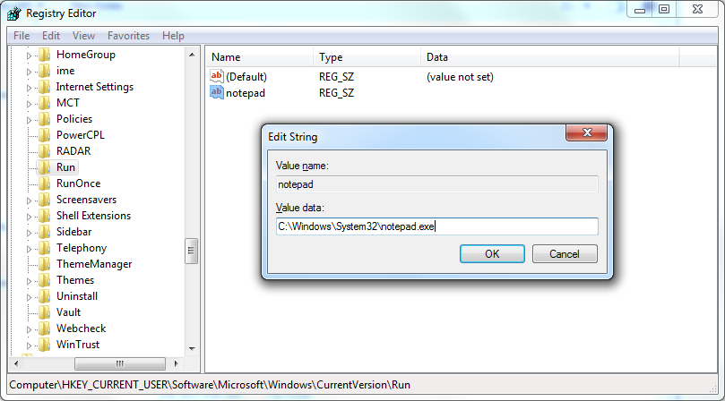
    - Close the Registry Editor window.
    - Restart Windows.
    - Log on to Windows as an administrator.
What happens when you log in?
____________________________________________________________________________________
    - Close all open Windows.
- Removing Programs from the startup folder and registry
    - Click Start > All Programs > Startup. Right-click Internet Explorer and select Delete. Click Yes on the Delete File window.
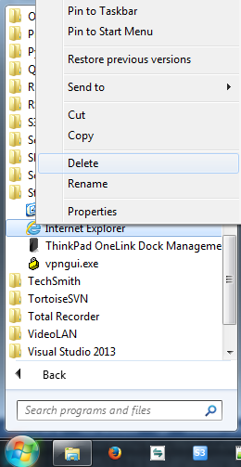
    - To remove Notepad from the Run folder in the Registry, click Start, type regedit and press Enter.
    - Expand the HKEY_CURRENT_USER > Software > Microsoft > Windows > CurrentVersion> Run
    - Right-click Notepad and select Delete. Click Yes for the Confirm Value Delete.
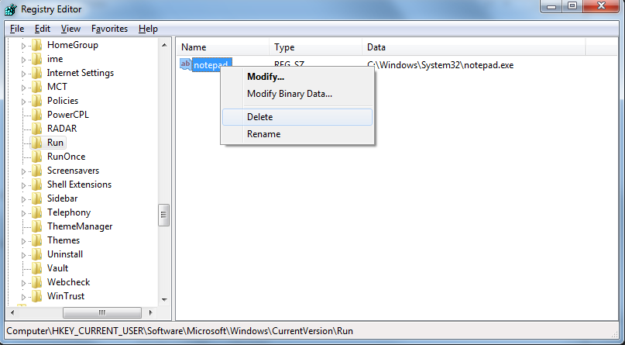
    - Restart Windows.
    - Log on to Windows as an administrator.
What happens when you log in?
____________________________________________________________________________________
    - Close all open windows.

Reflection
Why would a user want to stop programs from starting automatically?
_______________________________________________________________________________________
_______________________________________________________________________________________
_______________________________________________________________________________________
_______________________________________________________________________________________

